AASHTOWare Project Mobile Tester™
VERSION 2.1

Mobile Tester
Installation and User’s Guide

MARCH 2024

AASHTOWare is a registered trademark and service mark of AASHTO.  The following are registered trademarks of AASHTO:  - BAMS/DSS  - The AASHTOWare logo  - The AASHTOWare Project logo  - The AASHTOWare Project BAMS/DSS logo  - The AASHTOWare Project Bids logo  - The AASHTOWare Project Civil Rights & Labor logo  - The AASHTOWare Project Construction & Materials logo  - The AASHTOWare Project Cost Estimation logo  - The AASHTOWare Project Data Analytics logo  - The AASHTOWare Project Estimation logo  - The AASHTOWare Project Estimator logo  - The AASHTOWare Project FieldBook logo  - The AASHTOWare Project FieldBuilder logo  - The AASHTOWare Project FieldManager logo  - The AASHTOWare Project FieldNet logo  - The AASHTOWare Project Mobile Tester logo  - The AASHTOWare Project Preconstruction logo  - The AASHTOWare Project SiteManager logo  - The AASHTOWare Project TRACER logo  - The AASHTOWare Pavement ME Design logo | - The AASHTOWare Safety Analyst logo  The following are trademarks of AASHTO:  - The AASHTOWare Project Construction Administration logo  - The AASHTOWare Project Worksheet logo  - The AASHTOWare Project SiteXchange logo  The following are proprietary software products of AASHTO:  - AASHTOWare Project  - AASHTOWare Project BAMS/DSS  - AASHTOWare Project Civil Rights & Labor  - AASHTOWare Project Construction & Materials  - AASHTOWare Project Construction Administration  - AASHTOWare Project Cost Estimation  - AASHTOWare Project Data Analytics  - AASHTOWare Project Estimation  - AASHTOWare Project Expedite Archive Tool Utility  - AASHTOWare Project Interactive Data Model Utility  - AASHTOWare Project Meta-Delta Utility  - AASHTOWare Project Mobile Tester  - AASHTOWare Project Payroll Spreadsheet and Conversion Utility  - AASHTOWare Project Payroll XML Resource Kit  - AASHTOWare Project Preconstruction | - AASHTOWare Project SiteManager  - AASHTOWare Project SiteXchange  - AASHTOWare Project System Data Transfer Utility  - AASHTOWare Project Worksheet  - Project Entry Template for AASHTOWare Project  FieldManager and Mobile Inspector are registered trademarks of Info Tech, Inc.  The following are trademarks of Info Tech, Inc.:  - Estimator  - FieldNet  - Field Interviewer  The following are proprietary software products of Info Tech, Inc., and the State of Michigan:  - FieldBook  - FieldBuilder  - FieldManager  The following are proprietary software products of Info Tech, Inc.:  - AASHTOWare Project Bids  - Estimator  - FieldNet  - Field Interviewer  - Mobile Inspector  - SYNC Service for AASHTOWare Project  Infotech and the Infotech logo are registered trademarks of Info Tech, Inc.  Other product names are trademarks or registered trademarks of their respective owners.

© Copyright 2024 by the American Association of State Highway and Transportation Officials, Inc. All rights reserved. This document or parts thereof may not be reproduced in any form without written permission of the publisher. Printed in the United States of America. Prepared by Info Tech, Inc., DBA Infotech.

Contents
Prerequisites 5
Install Mobile Tester 7
Device Requirements 7
Access Mobile Tester 7
Setup: iOS Devices 7
Setup: Android Devices 8
Setup: Windows Devices 8
Google Chrome browser 8
Microsoft Edge browser 8
Set Up Required Data 9
Register Your Device 9
Mobile Tester Users 9
AASHTOWare Project System Administrators 9
Make Sample Record Tests Available in Mobile Tester 10
How it Works 10
Assign Users Contract-Specific Contract Authority 10
Designate Mobile Lab Units 11
Assign Users Source Authority 11
Sync AASHTOWare Project Data to Mobile Tester 12
Set Up Recommended Data 15
Automate the Mobile Tester Sync 15
Set Image Compression 15
Add Useful Links to Mobile Tester 16
User's Guide 19
Sync Mobile Tester 19
Create a Sample Record 19
Add Sample Details 19
Associate Contract Project Item Material Sets 22
Add Material Details 23
Add Location Details 23
Add Photos 24
Enter Test Run Data 24
Mark Sample Records Ready for Sync 25
Edit Sample Records Marked Ready for Sync 25
Access Useful Links 26
Support 26
Mobile Tester 26
Agency System Administrator 26
Appendix 27
Customize Agency Field Tests 27
Set Up Agency-Specific Field Tests 27
Include Calculations or Reference Specification Checks 28
Organize Tests by Lab Unit 29

Prerequisites
Thank you for trusting AASHTOWare Project Mobile Tester™ to aid in your field sampling efforts. To implement this mobile application, you'll need:
- AASHTOWare Project Construction and Materials™ 4.2 (or higher).
- SYNC Service for AASHTOWare Project™.
This Installation and User Guide is intended to help system administrators work together with field personnel to install AASHTOWare Project Mobile Tester on devices intended for field sampling support. It includes information about the necessary AASHTOWare Project™ data configurations, as well as instructions for field personnel.

Install Mobile Tester

Device Requirements
If you are using:
- An Apple mobile device with touch-screen interaction: iOS (verion 11.3 or higher) and the Safari browser.
- An Android device: The Google Chrome browser (version 65 or higher).
- A Windows device: The Google Chrome browser (version 65 or higher) or the Microsoft Edge browser (version 17.17063 or higher).

Access Mobile Tester
Because Mobile Tester is a progressive web app, you don't need to download it to your mobile device. Instead:
- Open a browser.
  - Note: Do not use a private or incognito browser mode because the app will not recognize you.
- Go to this URL: https://mobiletester.aashtowareproject.org/. Tap the Help tab to learn more about Mobile Tester.
  - Note: Depending on your agency’s policies, you may need to whitelist mobileinspectorsync.infotechfl.com and *.s3.amazonaws.com.

Setup: iOS Devices
- Caution: To ensure the integrity of field sampling data entered using iOS devices, you must dock the Mobile Tester web page to your Home screen before you register your device.
With https://mobiletester.aashtowareproject.org/ open in a Safari browser:
- Tap Share .
- Tap Add to Home Screen .
  - Note: If the Add to Home Screen option is not shown, scroll to locate it.
- Confirm the app name to display, or edit the name if you like.
- Tap Add.
The AASHTOWare Project Mobile Tester icon displays alongside your other Home screen icons, making it easy to open and ensuring the integrity of your data.

Setup: Android Devices
With https://mobiletester.aashtowareproject.org/ open in a Google Chrome browser, if the Add Mobile Tester to Home screen dialog box displays, tap it and then tap Add.
- Screenshot of the Add Mobile Tester to Home Screen Hyperlink
Otherwise:
- Tap Menu .
- Tap Add to Home screen.
- Tap Add.
The AASHTOWare Project Mobile Tester icon displays alongside your other Home screen icons.

Setup: Windows Devices
With https://mobiletester.aashtowareproject.org/ open in a:

Google Chrome browser
- Click Menu .
- Click Save and share > Install Mobile Tester.
- Click Install.

Microsoft Edge browser
- Click Menu .
- Click Apps > Install Mobile Tester.
- Click Install.
The AASHTOWare Project Mobile Tester icon displays alongside your other Home screen icons.

Set Up Required Data
After installing Mobile Tester, register your device and set up required data so that you can sync information between AASHTOWare Project and Mobile Tester.

Register Your Device

Mobile Tester Users
- Log in to your Windows, Android, or iOS device with your username.
  - Note: Mobile Tester registers one user per device. If you use a shared Windows computer or Android device, verify that you have logged in with a username unique to you.
- From your device home screen, open Mobile Tester.
- Tap Accept Terms and Register.
- On the Terms/Registration page, note your unique Device ID.
- Contact your AASHTOWare Project system administrator and provide them with the Device ID.

AASHTOWare Project System Administrators
- Log in to AASHTOWare Project.
- From the dashboard, locate the System Administration component.
- Click the Users link.
- Click the User ID link for the user who needs to register their Mobile Tester device.
- Click the Devices tab.
- Click New.
- Enter the user’s newly assigned Device ID.
- Select App Name > Mobile Tester.
- Enter a Description to help track which device id is associated with each device.
- Click Save.

Make Sample Record Tests Available in Mobile Tester

How it Works
Mobile Tester uses a variety of factors - contract authority, source authority, sample types, material action relationships, test assignment information, qualifications, agency options, and user roles - to determine which tests are available in the app.
Set up data in AASHTOWare Project so that Mobile Tester users can access the sample record tests they need in the field.

Assign Users Contract-Specific Contract Authority
Mobile Tester users must have contract-specific contract authority in order to complete tasks that require users to associate sample records to contracts.
- Log in to AASHTOWare Project.
- From the dashboard, locate the Construction component.
- Click the Contract Specific Authorities link.
- On the Contract Specific Authority Overview, click Add Contracts to a User.
- In the Add Contracts to a User window, select a User Role.
- Select Status, Effective Date, and Expiration Date, if applicable.
- Click the row to select multiple contracts from the list or use the Quick Find search box to search for contracts.
- Click Add to Contract Specific Authorities.
See Managing Contract Specific Authorities in the AASHTOWare Project online Help.
Agencies that sync Mobile Tester with:
- AASHTOWare Project 5.00 or lower: Can create sample records for contract item material set materials, which require contract-specific contract authority
- AASHTOWare Project 5.01 or higher: Can create sample records for contract item material set materials, as well as sample records for materials not associated with any contract. Beginning with version 5.01, you can use Mobile Tester to create sample records:
  - To test material not used on contracts.
  - To test material for a source inspection.
  - As part of a sample tester qualification exam.
  - To replicate contract samples for quality assurance programs.
  - As part of equipment or lab testing.

Designate Mobile Lab Units
Lab Units that receive the sample record tests from Mobile Tester users must be designated as Mobile in AASHTOWare Project.
- Log in to AASHTOWare Project.
- From the dashboard, locate the Reference Data component.
- Click the Destination Labs link.
- On the Destination Lab Overview, expand the row for the destination lab associated with the lab unit.
- Select the Mobile checkbox for each lab unit that will perform sample record tests for Mobile Tester users.
- Click Save.
See Maintaining Destination Labs in the AASHTOWare Project online Help. The system will identify which tests are covered by that lab unit’s testing qualifications and allow those tests to be passed to AASHTOWare Project Mobile Tester.

Assign Users Source Authority
Do your Mobile Tester users need source authority to access sample records, sample record tests, mix designs, and test agency views?
Yes, if:
- Your agency sets the Apply Source Authority to Samples, Tests, and Agency Views agency option to True,
AND
- The sample is associated with a primary source or primary facility.
  - Note: The Mix Design field displays only approved mixes for which you have source authority.
No, if:
- The sample is not associated with a primary source or primary facility,
OR
- The primary source or primary facility has a null value in the Source Management Level field and you are an agency user.

To assign source authority to Mobile Tester users:
- Log in to AASHTOWare Project.
- From the dashboard, locate the System Administration component.
- Click the Persons link.
- Click the Last Name link for the person who will use Mobile Tester.
- Click the Source Management Levels tab.
- Verify that the person has a source management level assigned. If needed, click New to add one.
- Click the User quick link.
- Click the Source Authority tab.
- Click New.
- Select the user's role in the Role ID - Description field.
- Select the All SML Access checkbox to assign the user to all source management levels.
OR
Select one source management level in the Source Management Level Name field.
- Select Status, Effective Date, and Expiration Date, if applicable.
- Click Save.

Sync AASHTOWare Project Data to Mobile Tester
After setting up the required data in AASHTOWare Project, it's time to sync the first batch of data to Mobile Tester.
- Log in to AASHTOWare Project.
- From the dashboard, click the global Actions menu > Execute Process.
- Select Bridge to Mobile Tester.
  - Note: To help ensure that all Mobile Tester users can access the most current data, consider scheduling future syncs. See Automate the Mobile Tester Sync.
- Click Execute.
  - Note: If you need to troubleshoot this process, click the global Actions menu > Open Process History to access output and error logs.
- From the mobile device home screen, open Mobile Tester.
- Tap the SYNC Data tab.
- In the Pending Records section, tap SYNC.

Set Up Recommended Data

Automate the Mobile Tester Sync
To help ensure that all Mobile Tester users can access the most current data, you can schedule the Bridge to Mobile Tester process to sync data as often as needed. Automating this sync eliminates the need for Mobile Tester users to manually sync each time they want to pass data between Mobile Tester and AASHTOWare Project.
- Log in to AASHTOWare Project.
- From the dashboard, click the global Actions menu > Execute Process.
- Select Bridge to Mobile Tester.
- Select Enable Scheduling.
- Select Schedule Frequency > Daily.
- Select a Start Date and Start Time.
- Select the Repeat Task Every checkbox.
- Enter how often you want to run this process. For example, 2 minutes.
- Click Schedule. See Scheduling a Process in the AASHTOWare Project online Help.
  - Note: If you need to troubleshoot this process, click the global Actions menu > Open Process History > Scheduled tab to access output and error logs. See Viewing Scheduled Processes in the AASHTOWare Project online Help.

Set Image Compression
In AASHTOWare Project, you can specify the file compression for images attached to sample records. If your agency:
use the Attachment Max File Size in Kilobytes agency option to specify the file compression for images attached to sample records. If your agency:
- Specifies a file size for the Attachment Recommended File Size in Kilobytes agency option, Mobile Tester will compress image files to that size.
- Leaves the recommended file size blank, but specifies the Attachment Max File Size in Kilobytes agency option, Mobile Tester will compress image files to that size.
- Leaves both agency options blank, Mobile Tester will compress image files to 1 MB to help ensure adequate storage space on mobile devices.
To verify your agency's settings for these agency options:
- Log in to AASHTOWare Project.
- From the dashboard, locate the System Administration component.
- Click the Agency Options link.
- In the Quick Find field, type Attachment.
- Review the Attachment Recommended Max File Size in Kilobytes and Attachment Max File Size in Kilobytes agency options.
  - Note: We recommend that agencies leave the Attachment Max File Size in Kilobytes agency option blank so that the system will not interfere with large files that you may need to import into AASHTOWare Project.
If you specify a maximum file size, you must also verify that the maxRequestLength setting will accommodate the maximum file size. See Server Configuration in the AASHTOWare Project online Help.

Add Useful Links to Mobile Tester
To ensure that your field employees have all the information they need at their fingertips, you can add agency-specific links to the Links tab in Mobile Tester.
- Log in to AASHTOWare Project.
- From the dashboard, locate the Reference Data component.
- Click the Code Tables link.
- In the Quick Find field, type Mobile.
- Click Mobile Tester Links.
- On the Code Table / Values Summary, click New.
- Type the Order in which this link will display in Mobile Tester, with 1 being the first link in the list.
- In the Value field, type the link text that will display in Mobile Tester.
- Type the URL in the Description field.
- Select an Obsolete Date, if needed.
- Click Save.
- To display these links in Mobile Tester, run the Bridge to Mobile Tester process. See Sync AASHTOWare Project Data to Mobile Tester.

User's Guide

Sync Mobile Tester
To sync information from AASHTOWare Project to Mobile Tester:
- Tap the SYNC Data tab.
- In the Pending Records section, tap SYNC.
  - Note: Some mobile devices are configured to display an Available Storage graphic on the SYNC Data page, while other devices are not. You do not need this graphic when syncing Mobile Tester, but if it displays on your device, IT Support can use the information when troubleshooting..
Only Use the Reset Database Button when Instructed by IT Support
Do not tap the Reset Database button unless you are speaking with IT Support and they ask you to do so.

Create a Sample Record
After syncing information from AASHTOWare Project to Mobile Tester:
- Tap the Queue tab.
- Tap the New button.
- Select a material.
The Sample Record page displays.

Add Sample Details
- Type the Sample Id or tap the Barcode button to scan it in. When scanning:
  - Allow cloudfront.net to access the device camera, if prompted.
  - If you have trouble scanning, select the device Camera you will use to scan the barcode, and the image Resolution.
  - Place the barcode in the middle of the rectangular highlight and hold the camera steady.
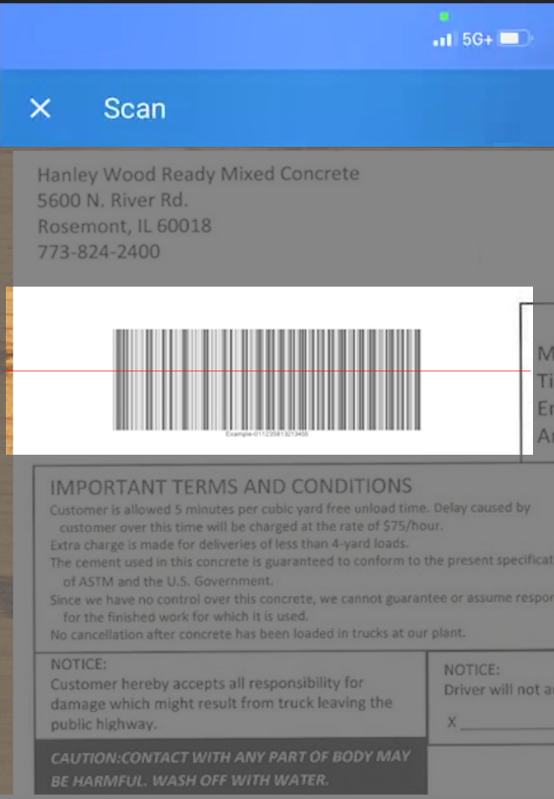
- An Example of the Mobile Tester Scan Screen During a Barcode Scan
- Select an Administrative Office.
  - Note: This field displays when agencies sync Mobile Tester with AASHTOWare Project 5.01 or higher.
If a user has more than one role in AASHTOWare Project, and one of those roles has All Contract Access, then the user will see all administrative offices in Mobile Tester.
To access a sample record in AASHTOWare Project that you synced from Mobile Tester, if the sample record includes an administrative office, you must be in a role that has administrative office authority for that office.
- Select a Date.

Associate Contract Project Item Material Sets
- In addition to creating sample records for contract item material set materials, agencies that sync Mobile Tester with AASHTOWare Project 5.01 or higher can also create sample records for materials not associated with any contract.
  - To test material not used on contracts.
  - To test material for a source inspection.
  - As part of a sample tester qualification exam.
  - To replicate contract samples for quality assurance programs.
  - As part of equipment or lab testing.
Follow your agency's guidance regarding when to associate contract project item material sets with sample records.
- On the Sample Record page, tap Add Contract Associations.
The Edit Contract Associations window displays..
- Expand a project record.
- Select all project item material sets you want to associate to this sample record.
- For materials where the sample record represents the same quantity and work location, enter:
  - Set Rep Qty for Selected: The represented quantity for those material sets.
  - Set Work Location for Selected: The work location for those material sets.
- Tap Save.
- On the Sample Record page, if you have not entered a quantity and work location for one or more associated material sets, enter:
  - Rep Qty: The represented quantity for each material set.
  - Work Location: The work location for each material set.

Add Material Details
- On the Sample Record page, select a Source (P/S).
- Select a Facility.
- Select a Source Material Facility Material Identification.
- Select a Brand.
  - Note: You must select a Source (P/S) and a Brand if the Brand Name Required field is selected for the material associated with the sample record in AASHTOWare Project.
- Select a Mix Design.
  - Note: The Mix Design field displays only approved mixes for which you have source authority.
- Select a Sample Type.
  - Note: Mobile Tester uses the sample type you select to filter the tests available for this sample record.
- Select an Acceptance Method.
- Select a Represented Qty and a Unit.
  - Note: If you associate contract project item material sets to this sample record, the Represented Qty and Unit fields do not display. Instead, enter Represented Qty for each associated material set. See Associate Contract Project Item Material Sets, below.

Add Location Details
- On the Sample Record page, type the coordinates for Latitude and Longitude.
Or, tap the Location button to fill the Latitude and Longitude fields with your device's GPS information. Your device may prompt you to allow the app to use your device’s location. If you decline, you will not be able to autofill GPS information, but you can still type the coordinates into the fields.
- Select a Station and a Station Plus.
- Select an Offset.
- Select a Seal Number.
- Select an Intended Use.

Add Photos

On Mobile Devices
- On the Sample Record page, tap the Camera button.
- Add a photo from the photo library on your mobile device.
OR
- Take a photo.
  - Note: Photos taken in Mobile Tester will not automatically be added to your photo library.

On Laptop or Desktop Computers
- On the Sample Record page, tap the Camera button.
- Add a photo from the photo library on your computer.

Enter Test Run Data
After creating a sample record, follow these steps to associate tests and enter test data:
- On the Sample Record page, if the sample record is locked, tap Unlock.
- On the Sample Record page, tap Tests.
  - Note: The Available Tests page indicates which tests your agency has selected as default, required, or optional. If you do not see the tests you expect, verify that you chose the correct sample type.
- Select the test associated with your lab unit.
- Select Add Run to add new data.
OR
- Select an existing test run to edit data.
- On the Test page, record all relevant information.
  - Note: Your agency may have configured this page to include a subset of the test run data fields displayed in AASHTOWare Project. For more information, see Maintaining Agency Fields in the AASHTOWare Project online Help.
- Tap the Back button.
- On the Available Tests page, select another test from the list to record additional test run data.
- After entering data for all relevant test runs, tap the Back button.

Mark Sample Records Ready for Sync
- Tap the Queue tab.
- In the Not Submitted section, locate the sample record you created.
- If this sample record and its tests should be included in the next sync to AASHTOWare Project, tap the Ready for Sync button. See Sync Mobile Tester.
  - Note: Mobile Tester locks the sample record.

Edit Sample Records Marked Ready for Sync
- In the Pending Sync section, locate the sample record you want to edit and tap to open it.
- Tap Unlock and edit the sample record information.
- Tap the Back button.
- In the Not Submitted section, tap the Ready for Sync button again.
- Tap the SYNC Data tab and then tap the SYNC button to send your sample to AASHTOWare Project. See Sync Mobile Tester.

Access Useful Links
To access links to other websites you may find useful when creating sample records and entering test run data, tap the Links tab. To add links to this page, your agency system administrator can add them to the Mobile Tester Links code table in AASHTOWare Project. For more information, see Maintaining Code Table Information in the AASHTOWare Project online Help.

Support

Mobile Tester
For assistance with installing and operating Mobile Tester, or to report software errors, contact our Customer Support department from 8:30 a.m. to 8:00 p.m. Eastern Time at:
- Phone: 844-915-2655
- Email: customer.support@infotechinc.com

Agency System Administrator
Mobile Tester uses a variety of factors - contract authority, source authority, sample types, material action relationships, test assignment information, qualifications, agency options, and user roles - to determine which tests are available in the app.
If you expect to be able to access and edit sample records, sample record tests, and test agency views, and are not able to do so, please contact your system administrator.

Appendix

Customize Agency Field Tests
Agencies maintain complex road construction data in a variety of ways. No one solution could suit them all. That’s why Mobile Tester and AASHTOWare Project are built to be flexible, allowing you to bring together agency-specific data with standard road construction data sets.

Set Up Agency-Specific Field Tests
You can use AASHTOWare Project's Agency Views to create agency-specific field tests for use in both Mobile Tester and AASHTOWare Project. Set yourself up for success in the same way that you would with a road construction project; Plan the data sets you want to unify and the functionality that meets your agency’s business needs.
For example, to create an agency-specific test method agency view that material testers can use in both Mobile Tester and AASHTOWare Project, you must mark as Mobile each of the fields that you want to sync to Mobile Tester.
- Log in to AASHTOWare Project.
- From the dashboard, locate the System Administration component.
- Click the Agency Entities link.
- Click the Name link for the agency entity where each field is stored.
- Scroll to the list of agency entity fields and locate the field you want to sync.
- Click the row Actions menu > Open.
- On the Agency Field Summary, locate the Validation Rules section and click New.
- Select Type > IsMobile.
- Click Save.
Mobile Tester is designed to use a subset of AASHTOWare Project agency view features. Keep the following in mind when designing agency views for Mobile Tester:
- Use one or both of these controls: Detail, List.
- Use one or more of these field types:
  - Datepicker
  - Dropdown
  - Text
  - TextArea
  - TextBox
- When designing agency views that display in both AASHTOWare Project and Mobile Tester, these features are available only in AASHTOWare Project:
  - Conditional formatting.
  - On Create code.
  - Calculations.
  - Reference specification checks.
See Include Calculations or Reference Specification Checks, below.

Include Calculations or Reference Specification Checks
When designing test method agency views that include calculations or reference specification checks, plan for field testers to view information and enter data in Mobile Tester while AASHTOWare Project handles the calculations and specification checks. Use this general workflow:
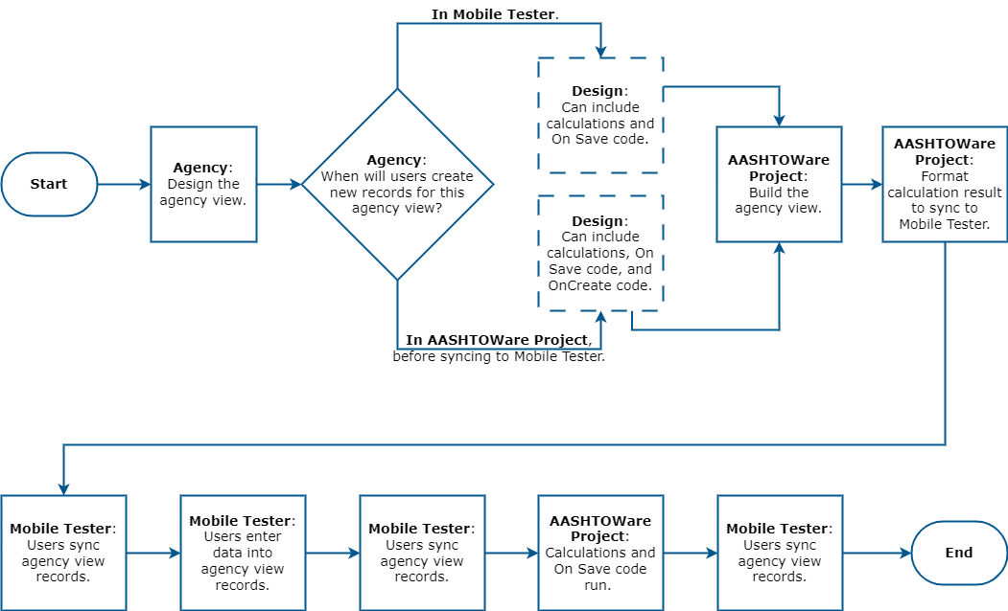
- High-Level Process to Design AASHTOWare Project Agency Views that Sync To Mobile Tester
When designing an agency view:
- The workflow that your agency uses will impact the design of your agency view. If the agency prefers users to create new records:
  - In AASHTOWare Project before syncing those records to Mobile Tester, then you may include OnCreate and On Save code when you design the agency view.
  - In Mobile Tester before syncing those records to AASHTOWare Project, then you may include On Save code when you design the agency view, but not OnCreate code.
- If you want Mobile Tester users to view the result of a calculation, you must store the result in a Text field that includes the IsMobile validation rule. See Set Up Agency-Specific Field Tests, above.

Organize Tests by Lab Unit
By design, AASHTOWare Project Mobile Tester allows users to view the necessary tests regardless of lab unit. However, each available Test in the app includes the Lab Unit name that is responsible for the test. To ensure that users can locate the correct tests, consider:
- Creating a central or template test and supporting agency view.
- Asking each Lab Unit to copy and rename the template test and agency view using a unique name.
Although this strategy requires additional data setup for test assignment information,it makes it quick and easy for users to locate the test they need.

